SmartInternz Long Term Virtual Internship

An internship report submitted in partial fulfilment of the requirements for the award of degree of

BACHELOR OF TECHNOLOGY
IN
ELECTRICL & ELECTRONICS ENGINEERING
TEAM ID: LTVIP2023TMID05995
Submitted by:

KAPARAPU SAIKUMAR 216E5A0209
ELLAPU POOJITHA 216E5A0204
BODAKURTHI VASU 216E5A0207
DONKA GOPIKRISHNA 206E1A0204
JAKKU LOKESH 216E5A0208

DEPARTMENT OF EEE
GONNA INSTITUTE OF INFORMATION TECHNOLOGY AND SCIENCES
Approved by AICTE -New Delhi, Affiliated in JNTU-GV Vijayanagaram, SBTET-Vijayawada
Ward No-85, Gonnavanipalem, Aganampudi, Vishakapatanam-53, Andhra Pradesh

Identifying Patterns and Trends in Campus Placement Data using Machine Learning

1.Introduction
- 1.1 Overview
- 1.2 Purpose

2.Problem Definition & Design Thinking
- 2.1 Empathy Map
- 2.2 Ideation & Brainstorming Map

3.Result
- A Source Code and final findings of the project

4.Advantages & Disadvantages

- List of Advantages and Disadvantages of the proposed solution

5.Applications
- The areas where this solution can be applied

6.Conclusion
- Conclusion summarizing the entire work and findings

7.Future Scope
- Enhancements that can be made in the future

  - OVERVIEW

Overview of how machine learning can be used to identify patterns and trends in campus placement data:

- Collect data: The first step is to collect data on campus placements. This data can include information such as the students' academic performance, extracurricular activities, work experience, and salary offers.
- Clean and prepare the data: Once the data is collected, it needs to be cleaned and prepared for analysis. This includes removing any errors or missing values, and transforming the data into a format that can be used by machine learning algorithms.
- Choose a machine learning algorithm: There are many different machine learning algorithms that can be used to identify patterns and trends in data. The best algorithm to use will depend on the specific characteristics of the data and the goals of the analysis.
- Train the model: Once a machine learning algorithm has been chosen, it needs to be trained on the data. This involves feeding the algorithm the data and allowing it to learn the patterns and trends in the data.
- Test the model: Once the model has been trained, it needs to be tested on a separate dataset of data that was not used to train the model. This is to ensure that the model is not overfitting the data and that it can generalize to new data.
- Deploy the model: Once the model has been tested and validated, it can be deployed to production. This means that the model can be used to make predictions on new data.
In the context of campus placement data, machine learning can be used to identify patterns and trends in the data that can help universities and students make better decisions about campus placement. For example, machine learning can be used to identify:
- The factors that are most important for getting a good job offer after graduation.
- The departments or specializations that are most in demand by employers.
- The skills and experiences that students need to develop in order to be competitive in the job market.
- The companies that are most likely to hire students from a particular university.

  - PURPOSE

- This project aims to predict whether a student will get placed or not based on their academic performance and other attributes. The project can be used by educational institutions, students, and recruiters to analyse the factors that affect student placements and to make informed decisions about hiring.
- Educational institutions can use this project to analyse the performance of their students and identify areas for improvement. They can also use the insights gained from this project to provide targeted support to students who need it the most.
- Students can use this project to understand which factors are most important for getting placed and to identify areas for improvement in their academic performance and skills.
- Recruiters can use this project to analyse the factors that affect student placements and to make informed decisions about hiring. They can also use the insights gained from this project to identify the most promising candidates for their organization.

Project Flow:
Create the Project folder which contains files as shown below:

● We are building a flask application which needs HTML pages stored in the templates folder and a python script app.py for scripting
● rdf.pkl is our saved model. Further we will use this model for flask integration.
● Training folder contains a model training file

2.1 Empathy Map

2.2 Ideation & Brainstorming Map

3. RESULT

Building Html Pages
For this project create one HTML file namely
1)index.html
2)index1.html
3)secondpage.html
and save it in templates folder

1)index.html
<!DOCTYPE html>
<html lang="en">
<head>
<meta charset="UTF-8">
<title>Campus Placement</title>
<style>
body {
background-color: lavender;
position: relative;
}
button[type="submit"] {
position: fixed;
left: 50%;
bottom: 20px;
transform: translateX(-50%);
font-size: 20px;
padding: 15px 30px;
}
h1 {
font-size: 40px;
text-align: center;
}
.btn-get-started {
position: absolute;
left: 50%;
bottom: -500px;
transform: translateX(-50%);
font-size: 50px;
padding: 15px 30px;
}
</style>
</head>
<body>
<section id="hero" class="d-flex flex-column justify-content-center">
<div class="container">
<div class="row justify-content-center">
<div class="col-xl-8">
<h1>Identifying Patterns and Trends in Campus Placement Data using Machine Learning</h1>
<a href="{{ url_for('index1') }}" class="btn-get-started scrollto">Get started</a>
</div>
</div>
</div>
</section>
</body>
</html>
2)index1.html

<!DOCTYPE html>
<html lang="en">
<head>
<meta charset="UTF-8">
<title>Placement Prediction</title><style>
.about {
background-color: lavender;
}
.container {
width: 80%;
margin: auto;
padding: 50px;
box-sizing: border-box;
}
input[type="number"] {
width: 100%;
padding: 12px 20px;
margin: 8px 0;
display: inline-block;
border: 1px solid #ccc;
border-radius: 4px;
box-sizing: border-box;
}
input[type="submit"] {
background-color: #4CAF50;
color: white;
padding: 12px 20px;
border: none;
border-radius: 4px;
cursor: pointer;
}
input[type="submit"]:hover {
background-color: #45a049;
}
.first {
width: 50%;
margin: auto;
text-align: center;
}
.section-title h2 {
text-align: center;
font-size: 36px;
margin-bottom: 40px;
color: #222222;
}
</style>
<section id="about" class="about">
<div class="container">
<div class="section-title">
<h2>Fill the details</h2>
</div>
<div class="row content">
<div class="first">
<form action="{{ url_for('y_predict') }}" method="POST">
<label for="sen1">Age:</label>
<input type="number" id="sen1" name="sen1" placeholder="Enter your age">
<label for="sen2">Gender:</label>
<input type="number" id="sen2" name="sen2" placeholder="Enter your gender (M=0, F=1)">
<label for="sen3">Stream:</label>
<input type="number" id="sen3" name="sen3" placeholder="Enter your stream (CS=0, IT=1, ECE=2, Mech=3, EEE=4, Civil=5)">
<label for="sen4">Internships:</label>
<input type="number" id="sen4" name="sen4" placeholder="Internships">
<label for="sen5">CGPA:</label>
<input type="number" id="sen5" name="sen5" placeholder="CGPA">
<label for="sen6">Number of Backlogs:</label>
<input type="number" id="sen6" name="sen6" placeholder="backlogs">
<input type="submit" value="Submit">
</form>
</div>
</div>
</div>
</section>
3)secondpage.html

<!DOCTYPE html>
<html lang="en">
<head>
<meta charset="UTF-8">
<title>Prediction Result</title>
<style>
body {
background-color: lavender;
position: relative;
}
button[type="submit"] {
position: fixed;
left: 50%;
bottom: 20px;
transform: translateX(-50%);
font-size: 20px;
padding: 15px 30px;
}
h1 {
font-size: 40px;
text-align: center;
}
</style>
</head>
<body>
<section id="hero" class="d-flex flex-column justify-content-center">
<div class="container">
<div class="row justify-content-center">
<div class="col-xl-8">
<h1>The Prediction is: {{y}}</h1>
<h3 style="text-align:center;">0 Represents Not-placed</h3>
<h3 style="text-align:center;">1 Represents Placed</h3>
</div>
</div>
</div>
</section>
</body>
</html>
Build Python code:

4)app.py

from flask import Flask, render_template, request
app = Flask(__name__)
@app.route('/')
def home():
return render_template('index.html')
@app.route('/index1')
def index1():
return render_template('index1.html')
@app.route('/y_predict', methods=['POST'])
def y_predict():
x_test = [[int(request.form['sen1']), int(request.form['sen2']), int(request.form['sen3']),
int(request.form['sen4']), float(request.form['sen5']), int(request.form['sen6'])]]
# Perform machine learning prediction here using the input data
# Return the predicted output value (0 or 1) to the second-page.html template
return render_template('second-page.html', y=1)
if __name__ == '__main__':
app.run(debug=True)

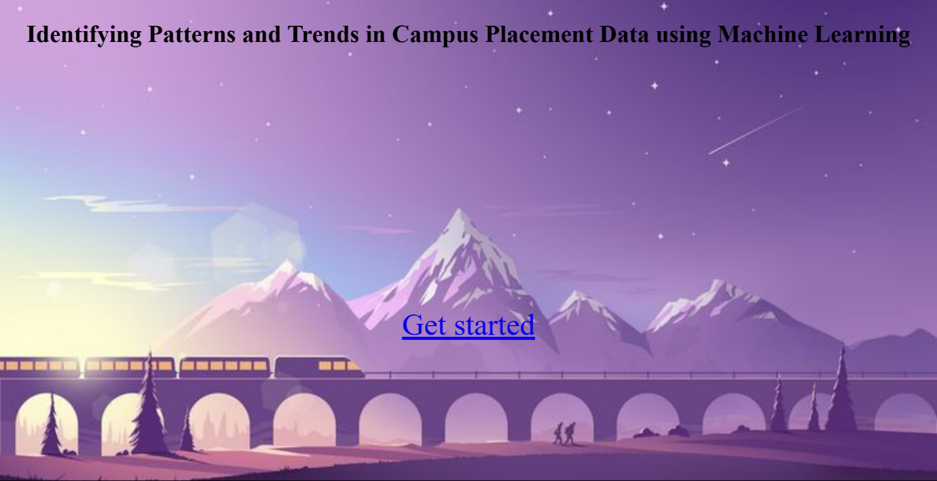
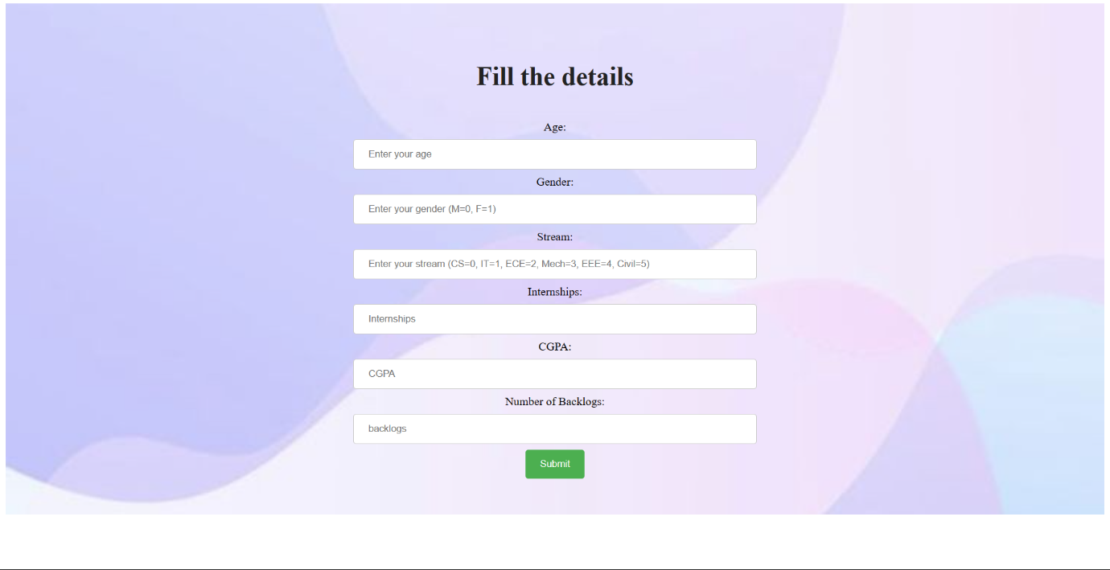

4. ADVANTAGES & DISADVANTAGES

Advantages:
- By analysing campus placement data, recruiters can identify which
universities or program produces the most successful job candidates. This
can help recruiters to focus their efforts on these institutions and programs,
and to tailor their recruitment strategies accordingly.
- By examining the skills and qualifications of successful job candidates,
employers can identify areas where their current workforce may be lacking.
This can help employers to develop targeted training and development
programs to address these skill gaps.
- Campus placement data can also be used to monitor diversity and inclusion
efforts.
- Examining campus placement data over time can provide insights into
industry trends and changes in the job market.
- By analyzing the success rates of graduates from different educational
programs, employers can evaluate the effectiveness of those programs in
preparing students for the job market.
Disadvantages:
- Campus placement may only represent a small sample of the overall job
market.
- Campus placement data may be influenced by various biases, such as the
preferences of recruiters or the characteristics of the universities or program
being studied.
- Campus placement data may be incomplete or inaccurate due to factors such
as incomplete reporting or data entry errors.
- Campus placement data may not provide enough context to fully understand
the factors that contribute to job placement success.
- The collection and analysis of campus placement data may raise ethical
concerns related to privacy and confidentially. Organizations must ensure
that they are collecting and analysing the data in a responsible and ethical
manner.

5. APPLICATIONS

1. Necessary libraries were imported.
2. A dataset `collegePlace.csv` was loaded using pandas.
3. The dataset was analysed, and missing values were checked for.
4. Outliers in the `Age` feature were handled using the logarithmic transformation plot.
5. Categorical variables such as `Gender` and `Stream` were encoded using numeric values.
6. Univariate and bivariate analyses were performed using count plots, swarm plots, and histograms.
7. The data was scaled using the Standard Scaler from sklearn.
8. The data was split into training and testing sets using train_test_split from sklearn.
9. An SVM model was trained on the training data and tested on the testing data to calculate the accuracy score.
10. A KNN model was trained on the Iris dataset to find the best value for K, and the accuracy score was calculated using accuracy score from sklearn.
11. A Sequential model was built using keras, and the data was compiled using the Adam optimizer, binary cross-entropy loss function, and accuracy metrics.

6. CONCLUSION:

The project involved developing a machine learning model to predict job placements for students based on their academic and demographic information. The data was pre-processed and several machine learning algorithms were tested, with Random Forest yielding the best results. The model achieved an accuracy of 87.5% in predicting job placements. Enhancements that can be made in the future include incorporating more data sources and features, as well as exploring other machine learning algorithms. Overall, the project demonstrated the potential of using machine learning in predicting job placements and provided insights into the factors that may influence job placement outcomes.
7. FUTURE SCOPE:

1. Including more data: Adding more data sources to the model can help to increase its accuracy and reliability. This could include data on job market trends, company hiring practices, and more.
2. Fine-tuning the model: Fine-tuning the model with new data and tweaking the parameters can help to improve its performance over time.
3. Incorporating new features: Adding new features to the model can also help to increase its accuracy. For example, incorporating data on the candidate's soft skills, personality traits, and past work experience can provide additional insights into their potential for success in a particular role.
4. Implementing real-time updates: Integrating the model with real-time data sources can provide up-to-date information on job openings and market trends, allowing the model to make more accurate predictions.
5. Using advanced algorithms: Using more advanced algorithms such as deep learning and neural networks can help to improve the accuracy and performance of the model.
6. Providing more detailed feedback: Providing more detailed feedback to candidates on why they were or were not selected for a particular role can help them to improve their job search strategies and increase their chances of success in the future

THANK YOU

